Networked Improvement Community (NIC) Team Structure
Three levels of learning in a NIC:
- Level A: Individual learning. Happens as a person engages in their work.
- Level B: Organizational learning. Happens across individuals within a workplace such as a school or district.
- Level C: Cross-organizational learning. Happens when organizations, such as schools or districts, learn from one another

Level C learning rapidly increases the social learning process when Levels A and B are actively engaged.

Improvement Networks: Accelerate Learning in Practice for Improvement
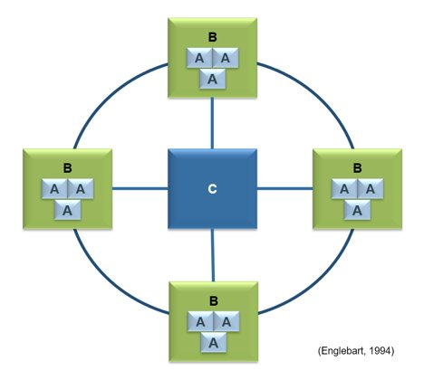

Networked Improvement Community: Role Descriptions
Problem Statement: [Enter Problem Statement Here]
Role | Description | Responsibilities/Tasks | Competencies
Project Champion(s)  [Insert Name and Affiliation] | The project champions are the leaders and key decisionmakers behind the NIC. The project champion has the power to commit resources to the project; helps recruit participants and advocate for ensuring the NIC process; and, assumes primary accountability for ensuring the success of the project. The project champion also facilitates regular NIC meetings and ensures the NIC’s long-term sustainability.  There can be more than one project champion, especially when there is more than one agency/organization involved. Regardless of the number of champions, one person should have final decisionmaking authority to support the NIC. | - Provides leadership and strategic direction for the NIC.  - Identifies key staff to serve on the NIC’s Improvement Hub.  - Works with improvement hub members to develop key competencies for NIC participants within pilot sites.  - Builds connections across agencies and staff to strengthen the NIC’s expert and relational core.  - Works with the leadership team to recruit NIC pilot sites and participants.  - Facilitates regular NIC meetings and guides improvement efforts.  - Oversees development and communication of the NIC’s vision, aims, and ongoing progress.  - Secures resources (e.g., human, monetary) to support the improvement effort. | - Ability to lead a large and diverse group of decisionmakers.  - Skilled at facilitating groups and building consensus among individuals with varying ideas and expertise.  - Ability and commitment to secure resources necessary to sustain the improvement effort.  - Deep experience and understanding of the NIC sponsoring organization’s (e.g., state agency, district) inner workings, including culture and politics.  - Ability to cultivate trusting relationships with a diverse group of stakeholders.  - Experience working with stakeholders across agencies and organizations on school improvement initiatives.  - Ability to make difficult decisions.  - Experience building cross-agency connections and breaking down organizational silos.  - Preferably, knowledge of NICs and familiarity with the implementation-science approach to improvement.
Improvement Hub Members  [Insert Names and Affiliation] | Members of the improvement hub include content experts, context experts, and data experts. Ideally, improvement hub members represent key stakeholder groups across all levels of the organizational system (e.g., classroom, school, district, and state) as well as partnering agencies.  Content Expert(s): Understands content area (e.g., pedagogy, systems of support, subject areas, and special subgroups) and problem under investigation; Aware of who knows what across the organization; and, can help others understand the content.  Context Expert(s): Understands the organization, roles and responsibilities of stakeholders, how stakeholders interact, and the local political and personal landscape; can see the problem from multiple perspectives.  Data Expert(s): Understands the organization’s data systems; has expertise in data collection, extraction, and visualization; can help others interpret and use data. | - Leads and/or participates in regular NIC meetings.  - Applies expertise and thought leadership to guide the improvement effort.  - Collaborates with project champion to develop the problem statement.  - Supports other tasks as assigned. Examples include recruiting members, facilitating data agreements, drafting memorandums of understanding (MOUs), developing data collection protocols, codesigning interventions, determining measures and protocols utilized for indication of fidelity of implementation, collecting and analyzing data, and providing expertise to guide the improvement effort. | - General responsibilities beyond content, context, and/or research/data expertise:  - Ability and commitment to secure resources necessary to sustain the improvement effort.  - Proven experience developing trusting relationships with diverse stakeholder groups.  - Experience working with diverse stakeholders across agencies and organizations on school improvement initiatives.  - Experience building cross-agency connections and breaking down organizational silos.  - Preferably, a familiarity with the implementation-science approach to improvement.
Site-Based Teams  [Insert Name and Affiliation] | Site-based team members (e.g., district and/or school leaders) may also serve on the leadership team. They provide essential ground-level insight and feedback to support the NIC improvement process. Site-based leads also support recruitment, coordination, and communication with site-based teams who pilot new programs/strategies. | - Participates in regular (e.g., weekly/biweekly) NIC meetings.  - Provides implementation feedback to the implementation hub.  - Coordinates and communicates feedback and serves as a liaison between frontline workers (e.g., teachers) and the NIC implementation hub.  - Leads execution of key tasks to support the improvement effort. Examples include participating in NIC leadership team activities, recruiting members to pilot-test solutions, serving as liaison between frontline workers and the leadership team, assisting in the development of data collection protocols, facilitating data sharing agreements, brokering the sharing of data, and supporting data collection and analysis activities. | - Skilled in leading site-based improvement efforts.  - Experience implementing the Plan-Do-Study-Act cycle of inquiry use.  - Willingness to oversee pilot testing and support the Plan-Do-Study-Act inquiry cycle.
Local End Users  [Insert Name and Affiliation] | Local end users (e.g., teachers, students) provide the “boots on the ground” implementation and feedback to NIC members.  They implement school/classroom interventions, participate in data collection activities, and provide ongoing feedback about the intervention. Frontline workers may also serve on the NIC improvement hub. | - Willingness to pilot new solutions to problems in a school or classroom setting.  - Participate in data collection activities.  - Provide implementation feedback to the NIC improvement hub.  - Participates regularly in NIC meetings (or as available, depending on the level of involvement). | - Willingness to participate in testing new solutions to ongoing problems.  - Willingness to provide formal and informal feedback to support the improvement process.

