Establishing the Measurement Infrastructure

Virtual Meeting Facilitation Guide

[Date], [Approx. 90-Minute Time Slot]

Objectives:
- Understand the purpose and uses of measurement in a Networked Improvement Community (NIC)
- Understand how to collect and use data to evaluate and support an improvement initiative
- Create a plan to evaluate a theory of action and conduct rapid cycles of improvement

Time* | Topic | Activity | Learning Objectives | Resources
5 min. | Welcome and Introductions |  | - Welcome participants and provide time for new participants to introduce themselves. Ask new members to share their name, position/title, organization affiliation, and core job responsibilities/expertise.  - Summarize the previous meeting objectives and outcomes.  - Introduce key objectives for this meeting (see above). | - Agenda
35 min. | Establishing the Measurement Infrastructure | Presentation | - Using the PowerPoint (PPT) presentation, provide an overview for developing a measurement infrastructure in a NIC context.  - Allow time for discussion and Q&As. Ask participants to share personal experiences when they may have used measures for making summative determinations or for continuous improvement.  - What measures do participants use to make summative determinations (evaluation)? What challenges emerge in using these measures to influence improvement? Explore challenges related to frequency, sensitivity of measures, practicality, etc.  - What measures do participants use for continuous improvement? What challenges emerge in using these measures to influence improvement? How have participants addressed these challenges?  - What questions or ideas emerge from this presentation that you would like to discuss in more depth? | - PPT Presentation
15 min. |  | Revisit NIC Representation | - Revisit the NIC and stakeholder representation. What groups are not represented? Are any groups’ voices missing, and who might be willing to represent these missing voices as a new NIC?  - How might we reorganize our existing NIC to create more efficiency in the work process and maximize the perspectives of all NIC members?  - Determine who will reach out to any prospective NIC members.  - Determine next steps to support a potential reorganization of the NIC.
45 min. |  | Plan for How the Theory of Action Will Be Evaluated over Time | - Identify extant data that can be treated as evaluation measures to monitor performance on long-term goals.  - Identify and/or develop data collection tools/measures that can be used to examine levels of implementation across inputs, outputs, and short- and mid-term outcomes.  - Create a table to describe how each component in the theory of action—from inputs to outcomes—will be measured. In each row, include a specific component to be measured. In each column, create the following headings:  - Data to be collected (e.g., observation, survey),  - Measures to be used (e.g., classroom walk-through checklist, climate survey),  - Data collection/reporting frequency (e.g., quarterly, annually), and  - Data review frequency (e.g., quarterly, annually). | - PPT Presentation  - Attachments 1-4 (below)
20 min. |  | Plan for Development of Practical Improvement Measures | - Review the list of root causes generated through the “why” process and/or documented in a fishbone diagram. Identify one or two of the most high-leverage root causes to address. A high-leverage root cause is one that: (1) can be addressed with relative ease, and (2) if addressed effectively, would lead to significant improvements on one or more outputs and/or short-term outcomes.  - Create a logic model to depict how the proposed change (resources/inputs) will improve outputs and/or short-term outcome(s).  - Identify improvement measures/data for monitoring implementation of the resources/inputs and resulting change in outputs/short-term outcomes within the logic model. Improvement measures should be easily and frequently collected/reported, proximal to the end user, and sensitive to change. | - PPT Presentation  - Attachments 1-4 (below)
10 min. | Wrap Up and Next Steps |  | - Assign follow-up activities, which may include finalizing the logic model, developing practical measures, creating systems to automate data collection and reporting, or creating/adopting new data reporting tools (e.g., data dashboard).  - Secure “units” (e.g., schools, leaders, teachers) to engage in the improvement effort.  - Prepare a timeline for implementing rapid improvement cycles (plan-do-study-act) and carrying out the evaluation.
*Times are estimates only. Time may fluctuate based on the nature of the discussion, group size, and meeting format (e.g., face-to-face vs. virtual).

Attachment 1. Three Uses for Measurement
Uses | Primary Purpose | Sample Research Questions | Common Features | Grain Size | Strengths | Limitations
Accountability | Make Summative Determinations | Which schools need intervention? | Examines global performance.  Typically reported annually (or at the end of an implementation cycle). | Distal | Useful for identifying persistent problems in performance or for identifying positive deviants.  Useful for examining implementation distally, or examining relationships between implementation and outcomes. | Insensitive to small-scale changes in practice.  Highly standardized; causes of performance differences are complex and opaque.
Theory Development and Testing | Make Summative Determinations | Does summer credit recovery improve graduation rates?  Did professional development X improve teachers’ classroom practices? | Used to test relationships across a causal chain (does X affect Y and/or Z?). | Varies | Useful for evaluating the efficacy of a theory of action or comparing differences between units (e.g., individuals, schools).  Useful for determining for whom, how, and under what conditions an intervention works. | Measures typically take time to develop and administer; not informative for rapid improvement.  Administration is time-consuming and often impractical because it is separate from daily practice.
Practical | Inform Continuous Improvement | If I change the way I provide feedback to students, will it improve students’ mastery of key concepts? | Measures are brief, frequently administered, and embedded in daily work.  Constructs measured are a direct focus of the improvement work and tied to a theory of action. | Proximal | Measures are easy to collect and sensitive to change; integrated into existing practice.  Measures prioritize predictive validity (i.e., how well does the measure predict future behavior?) across units (e.g., students, teachers) as the intervention is introduced in new sites. | Usually these measures need to be developed, and they often require web-based systems for rapid collection and reporting.  Measures relevant in one context may not be relevant, or may take on a different meaning, in another context.
Note: Table above adapted from Yeager, D., Bryk, A., Muhich, J., Hausman, H., and Morales, L. (2013). Practical measurement. Stanford, CA: Carnegie Foundation for the Advancement of Teaching. Available at: https://www.carnegiefoundation.org/wp.

Attachment 2. Unpacking the Measurement Infrastructure
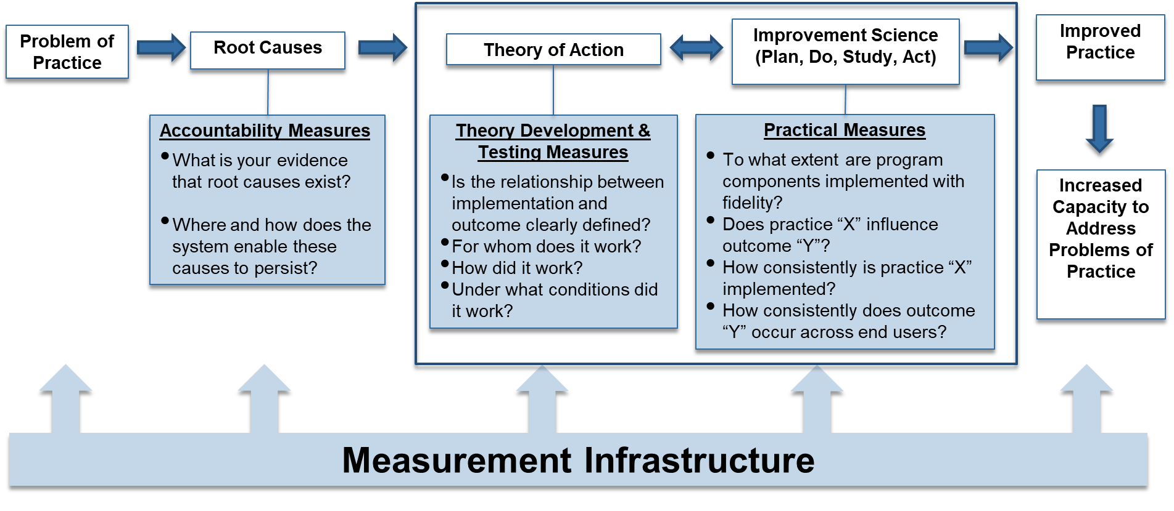

Attachment 3. Theory of Action: Improving the Postsecondary Pipeline
Grade 9-12 Students
More Students Meet College Application and Workforce Requirements
More Students Access Rigorous and Relevant Coursework
Admissions Testing, Opportunities for Workforce Experience
Increased Enrollment in Rigorous and Relevant Coursework
Increased Support for Students Through Their Student Plans
School-Wide Training to Support Students Enacting Their Plan
High-Quality Curriculum
and Courses
Restructured School Schedule and Courses
More Students Apply to College or Are Placed in the Workforce
Financial Support and Placement Opportunities
Rigorous and Relevant Coursework
Admissions Tests and Opportunities
Increase Postsecondary Success Rate
Increase Postsecondary Success Rate

Initiate Rapid Improvement Cycle
Target: Grade 12

Attachment 4. Measurement Infrastructure to Support Evidence Collection
